Below is a screen shot from website: <https://docs.aave.com/developers/tutorials/performing-a-flash-loan/...-with-remix>

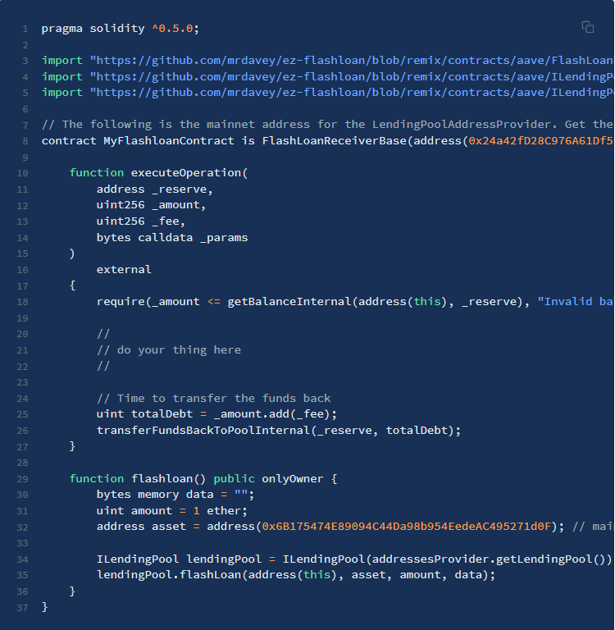 “Performing Flash Loan with Remix “

Arbitrage goes in “do your thing here” bit.